**SAMPLING AND RECONSTRUCTION OF SIGNAL**

**Date:** 15/01/2019

**Aim: Study of Sampling and Reconstruction of signal. Verify Nyquist criteria. Model ST21O1 W kit, connecting wires, CRO/DSO**

**Apparatus:** Model ST 2151 W kit, connection wires, CRO/DSO

**Sampling Theory:**

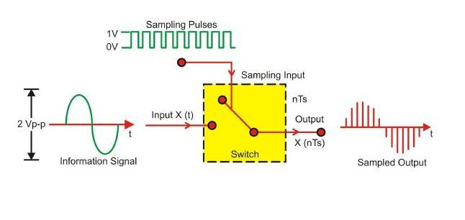

**Procedure:**

**A. Set up for Sampling and reconstruction of signal.**

Initial set up of trainer:

Duty cycle selector switch position: Position 5

Sampling selector switch: Internal position

1. Connect the power cord to the trainer. Keep the power switch in ‘Off’ position.
2. Connect 1 KHz Sine wave to signal Input as shown in Fig.1.1.
3. Switch ‘On’ the trainer's power supply & Oscilloscope.
4. Connect BNC connector to the CRO and to the trainer’s output port.

You can observe the process of step-by-step generating sine wave signal from Square wave of 1 KHz at TP3, TP4, TP5 and TP6 respectively.

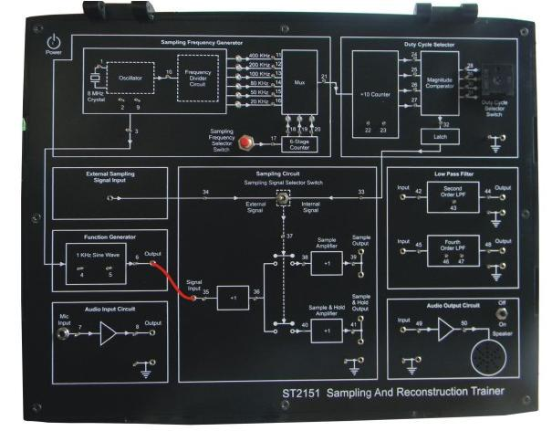

Fig. 1.1. Connection diagram for sampling a signal

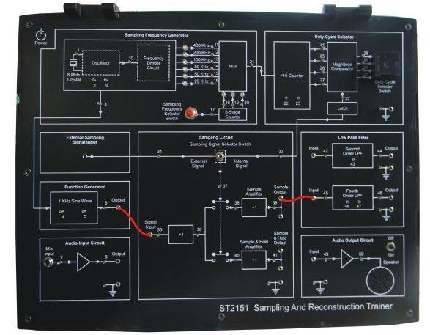

Fig. 1.2. Connection diagram for reconstruction of a sampled signal

**B**. **Set up for effect of Sample Amplifier and Sample and Hold Amplifier on reconstructed signal.**

**Set up for effect of II order and IV order Low Pass Filter on reconstructed signal.**

Initial set up of trainer:

Duty cycle selector switch position: Position 5

Sampling selector switch: Internal position

1. Connect the power cord to the trainer. Keep the power switch in ‘Off’ position.
2. Connect 1 KHz Sine wave to signal Input.
3. Switch ‘On’ the trainer's power supply & Oscilloscope.
4. Connect BNC connector to the CRO and to the trainer’s output port.
5. Select sampling frequency of 8 KHz by Sampling Frequency Selector Switch pressed till
6. KHz signal LED glows.
7. Observe 1 KHz sine wave and Sample Output (TP39) on oscilloscope. The display shows
8. KHz sine wave being sampled at 8 KHz, so there are 8 samples for every cycle of the sine wave.
9. Connect Sample Output to Fourth Order low pass filter Input as shown in figure 1.2. Observe the filtered output (TP48) on the oscilloscope. The display shows the reconstructed 1 KHz sine wave.
10. Similarly observe the sampled 1 KHz sine wave at and Sample and Hold Output (TP41) on oscilloscope. The display shows 1 KHz sine wave being sampled and hold signal at 8 KHz. Connect Sample and Hold Output to Second Order low pass filter Input and observe the filtered output (TP44) on oscilloscope. The display shows the reconstructed1 KHz sine wave.
11. By pressing Sampling Frequency Selector Switch, change the sampling frequency from 2 KHz, 5 KHz, 10 KHz, 20 KHz up to 40 KHz (Sampling frequency is 1/10th of the frequency

indicated by the illuminated LED). Observe how Sample output (TP39) and Sample and Hold Output (TP41) changes in each case.

**Sample Observations:**

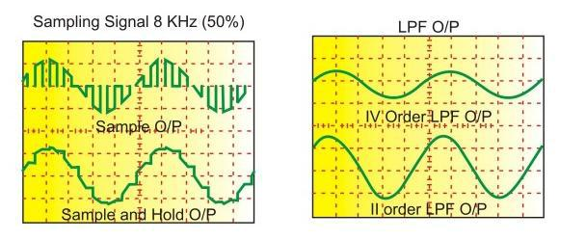

**Observation Table:**

**Sample Output:**

|  |  |  |  |  |
| --- | --- | --- | --- | --- |
| **Sr.**  **No.** | **Low Pass Filter** | **Sampling Frequency**  **(kHz)** | **Frequency of Signal**  **(Hz)** | **Peak to Peak Voltage**  **Vp-p (V)** |
| 1. | 0th Order | 20 | 999.603 | 2.48 |
| 50 | 999.597 | 2.74 |
| 80 | 999.599 | 2.80 |
| 100 | 999.592 | 2.88 |
| 200 | 999.618 | 2.94 |
| 400 | 999.685 | 3.36 |
| 2. | 2nd Order | 20 | 999.619 | 3.08 |
| 50 | 999.596 | 3.76 |
| 80 | 999.598 | 3.28 |
| 100 | 999.584 | 3.40 |
| 200 | 999.589 | 3.52 |
| 400 | 999.589 | 2.56 |
| 3. | 3rd Order | 20 | 999.601 | 2.80 |
| 50 | 999.600 | 1.88 |
| 80 | 999.609 | 1.48 |
| 100 | 999.575 | 1.44 |
| 200 | 999.580 | 1.56 |
| 400 | 999.580 | 1.44 |

**Sample and Hold Output:**

|  |  |  |  |  |
| --- | --- | --- | --- | --- |
| **Sr.**  **No.** | **Low Pass Filter** | **Sampling Frequency**  **(kHz)** | **Frequency of Signal**  **(Hz)** | **Peak to Peak Voltage**  **Vp-p (V)** |
| 1. | 0th Order | 20 | 999.586 | 3.28 |
| 50 | 999.620 | 3.50 |
| 80 | 999.584 | 3.56 |
| 100 | 999.602 | 3.64 |
| 200 | 999.590 | 3.40 |
| 400 | 1000.000 | 3.12 |
| 2. | 2nd Order | 20 | 999.603 | 4.28 |
| 50 | 999.610 | 4.00 |
| 80 | 999.596 | 4.16 |
| 100 | 999.599 | 4.00 |
| 200 | 999.596 | 3.88 |
| 400 | 999.601 | 4.96 |
| 3. | 3rd Order | 20 | 999.602 | 2.64 |
| 50 | 999.603 | 3.52 |
| 80 | 999.595 | 3.20 |
| 100 | 999.590 | 3.12 |
| 200 | 999.605 | 3.00 |
| 400 | 999.600 | 3.40 |

**Output Waveforms:**

**Input Signal:** Sine Wave at 1kHz

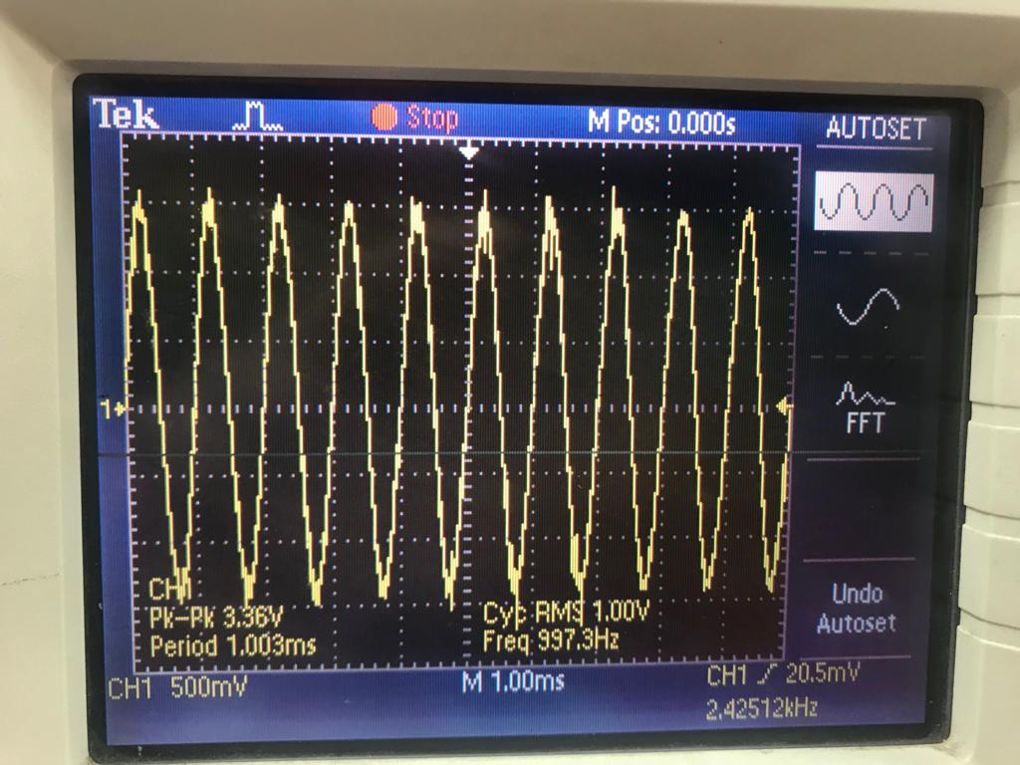

**Sample Output: (i)** Without LPF at sampling frequency of 200kHz and 400kHz respectively

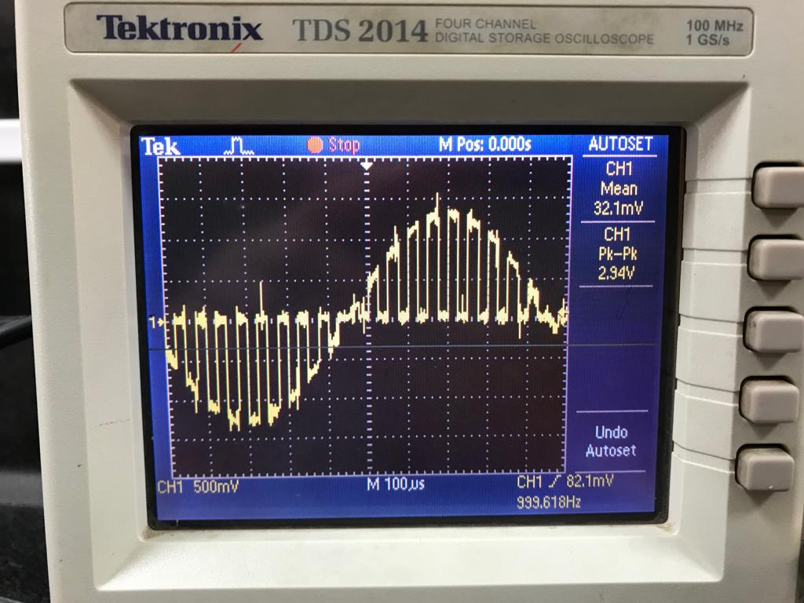 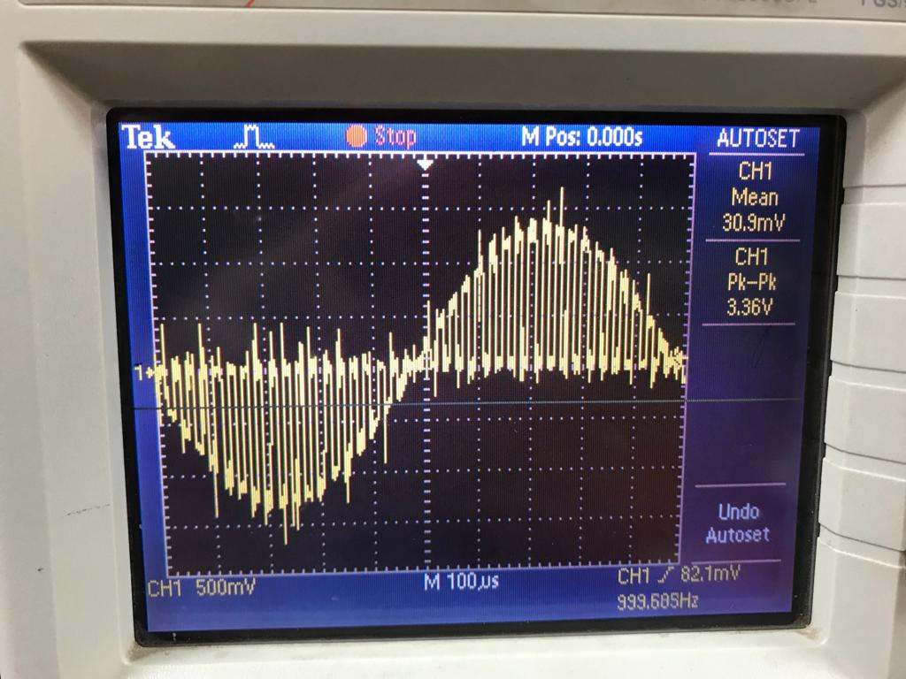

**(ii)** With 2nd Order LPF at sampling frequency of 200kHz and 400kHz respectively

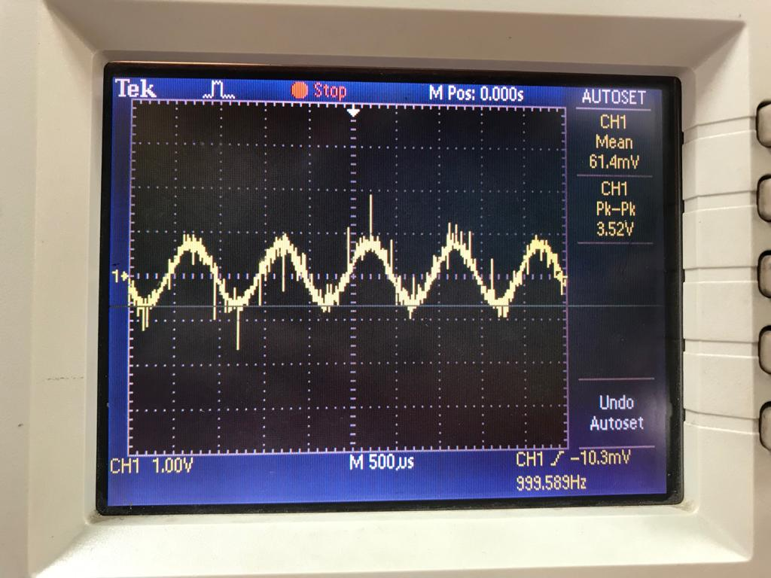 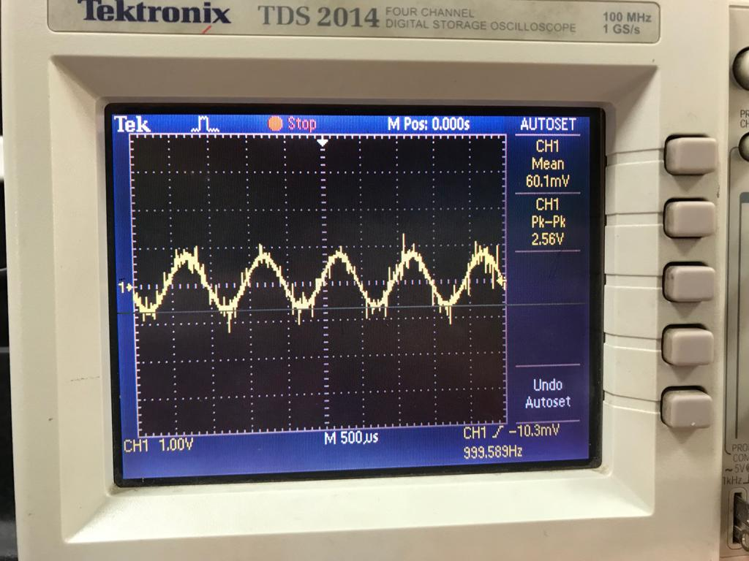

**(iii)** With 4th Order LPF at sampling frequency of 200kHz and 400kHz respectively

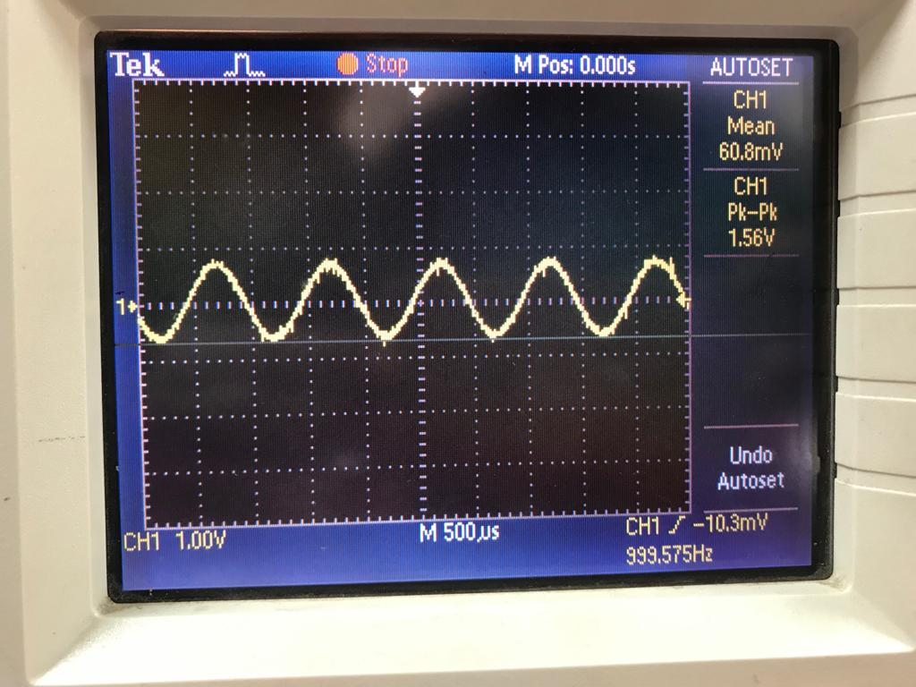 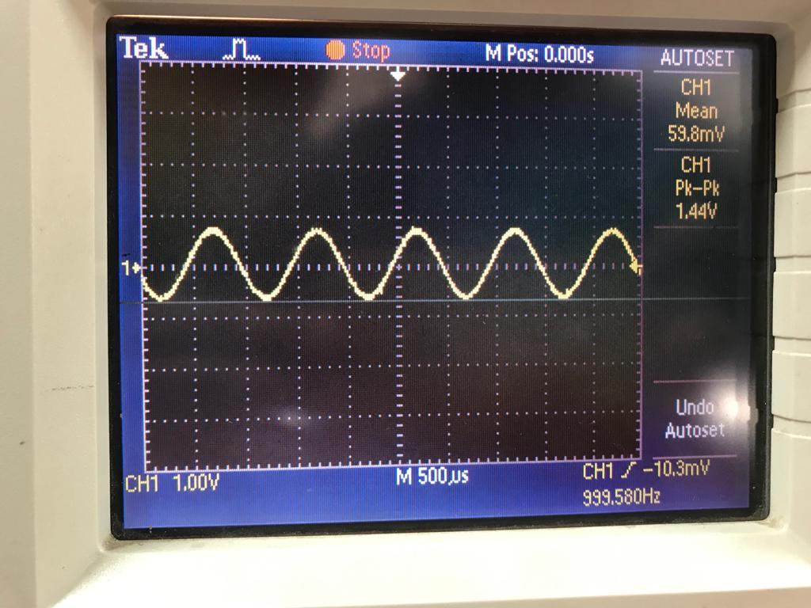

**Sample and Hold Output: (i)** Without LPF at sampling frequency of 200kHz and 400kHz respectively

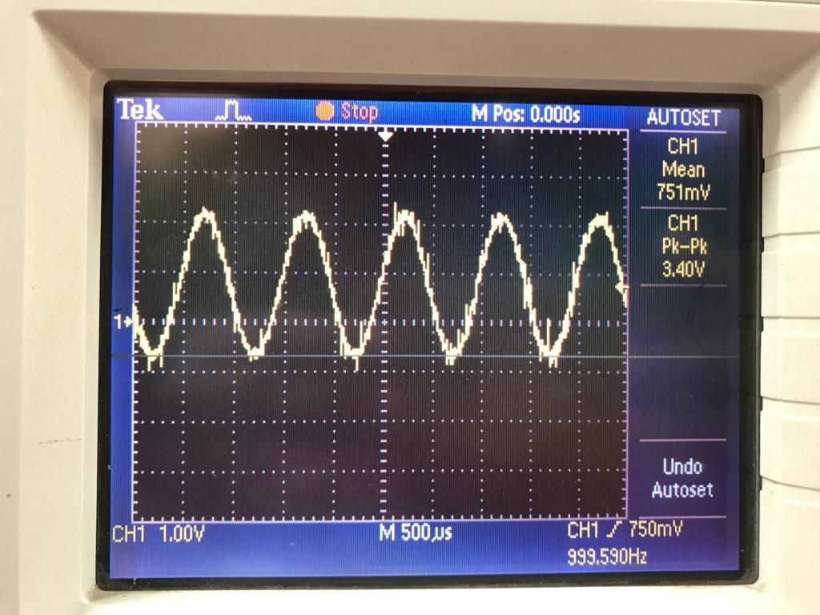 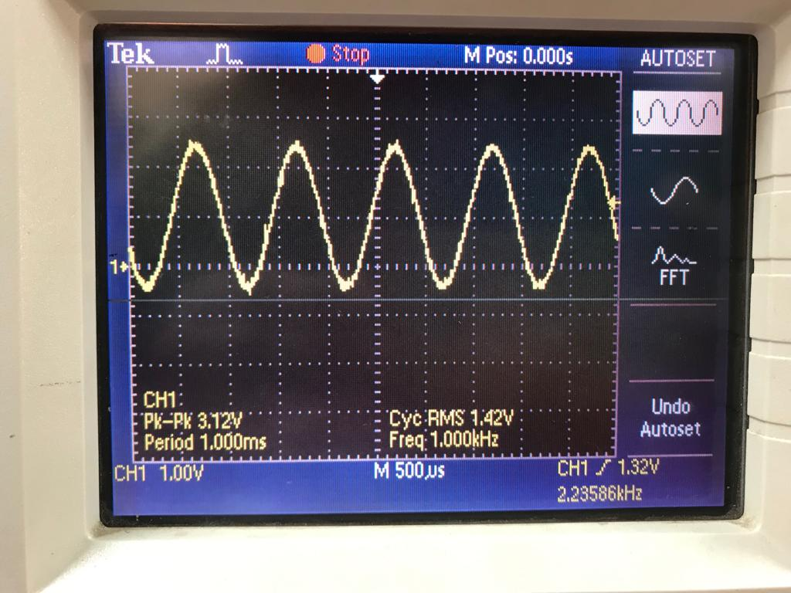

**(ii)** Using 2nd Order LPF at sampling frequency 200kHz and 400kHz respectively

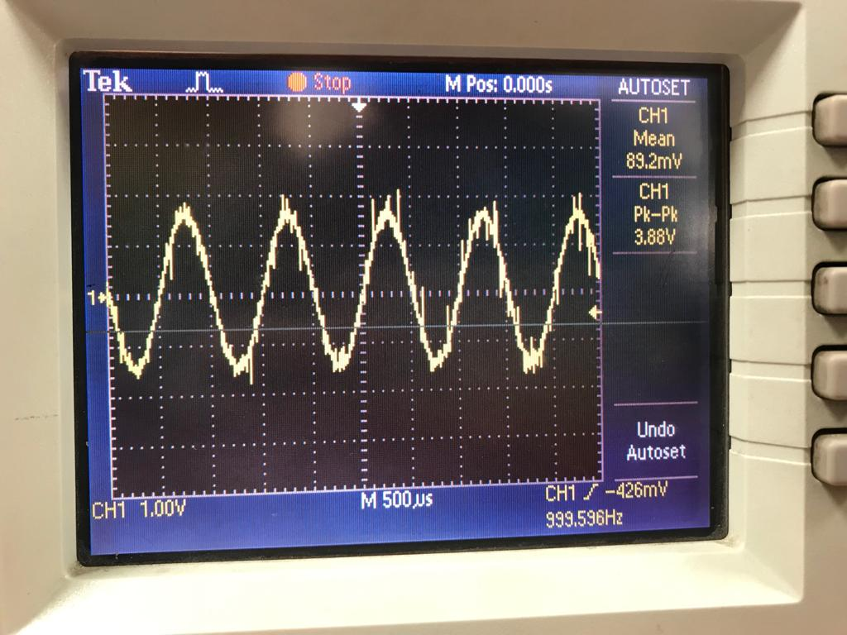 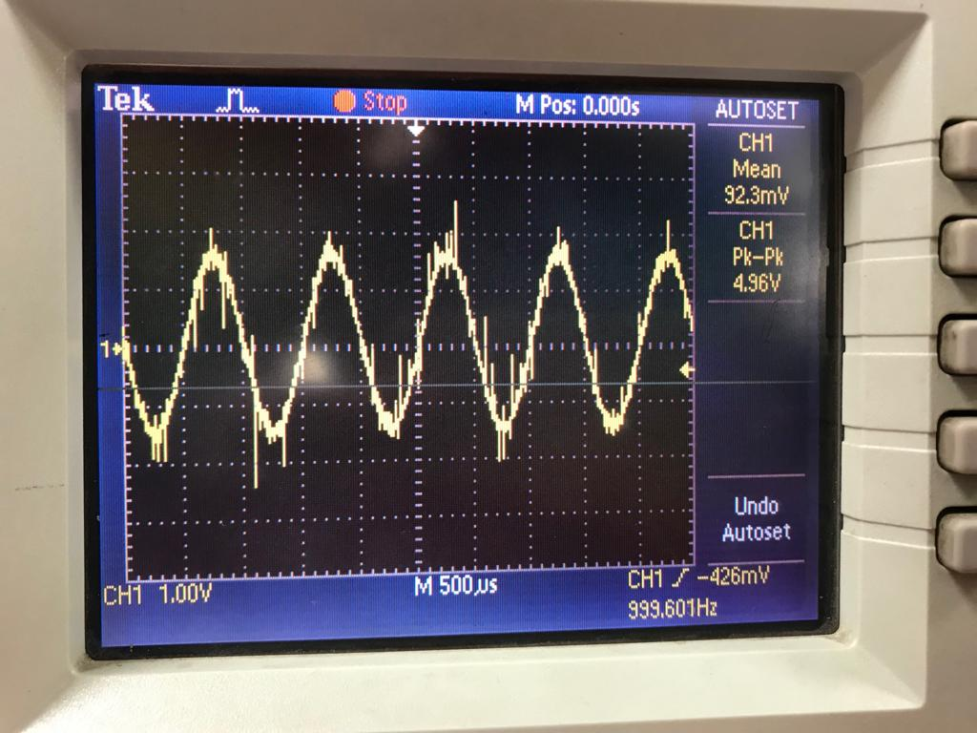

**(iii)** Using 4th Order LPF at sampling frequency 200kHz and 400kHz respectively

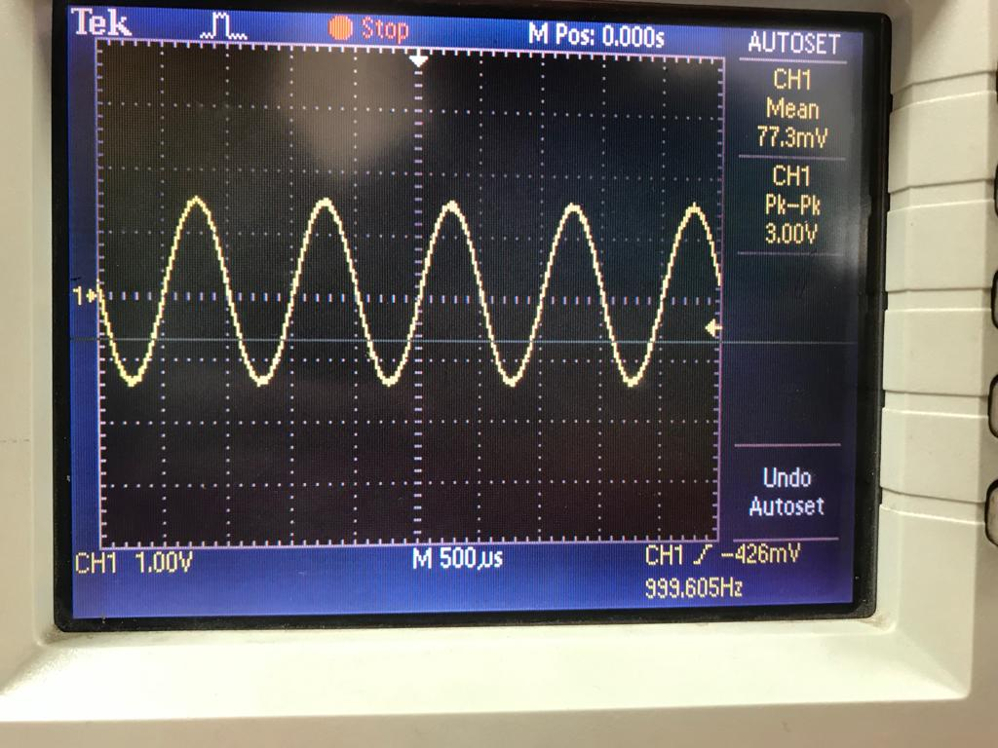 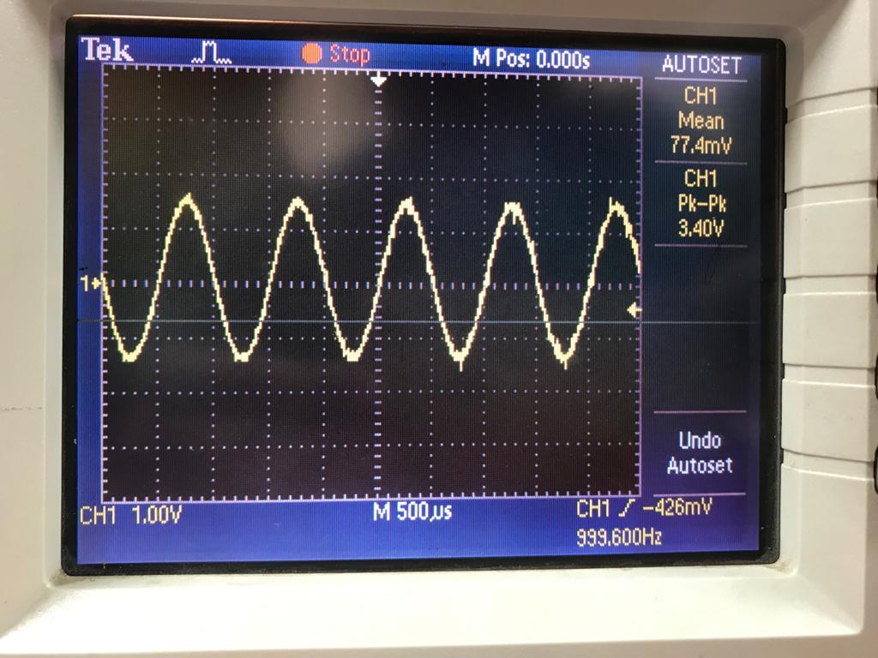

**Conclusion:**

**Remarks:** **Signature:**